Jeff Sherard
CSC160C11
7/20/2013

Documentation for Ch08_Ex14 Program

Problem Analysis

A company hired 10 temporary workers who are paid hourly and you are given a data file that contains the last name of the employees, the number of hours each employee worked in a week, and the hourly pay rate of each employee.

Write a program that:

- computes each employee’s weekly pay and the average salary of all the workers.
  - If the number of hours worked in a week is more than 40 hours, then the pay rate for the hours over 40 is 1.5 times the regular hourly rate.
- outputs the weekly pay of each employee, the average weekly pay, and the names of all the employees whose pay is greater than or equal to the average pay.

Use two parallel arrays: a one-dimensional array to store the names of all the employees, and a two-dimensional array of 10 rows and 3 columns to store the number of hours an employee worked in a week, the hourly pay rate, and the weekly pay.

The program must contain at least the following functions—a function to read the data from the file into the arrays, a function to determine the weekly pay, a function to output the names of all the employees whose pay is greater than or equal to the average weekly pay, and a function to output each employee’s data.

Algorithm

- Define variables:

- Get input:

ch8_Ex14Data.txt

- Calculate functions:

- function to read the data from the file into the arrays

readData( )

two parallel arrays:

one-dimensional array to store the names of all the employees
two-dimensional array of 10 rows and 3 columns to store the number of hours an employee worked in a week, the hourly pay rate, and the weekly pay

- function to determine the weekly pay

weeklyPay( )

if hours < 40
weekly pay = hours * payrate/hour = $$ / week

if hours>40
weekly pay = ((hours-40)*1.5 + 40) * payrate/hour = $$ / week

- function to output the names of all the employees whose pay is greater than or equal to the average weekly pay

avgWeeklyPay( )

avg weekly pay = (weekly pay[0] + …. + weekly pay[9]) / 10

if weekly pay[0]…[9] >= avg weekly pay
list employee nam

- function to output each employee’s data.

outputFunction( )

- Output:
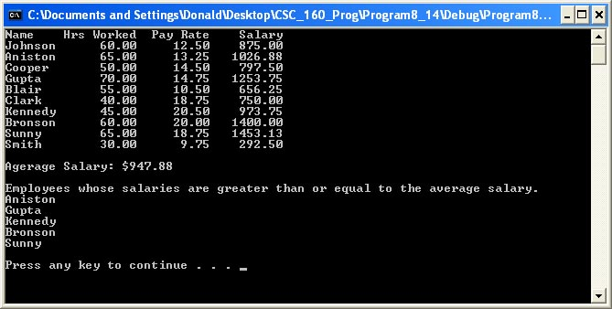

User Documentation

To run the program the user will double click Ch08_Ex14.exe located on the C drive. After the program has loaded and the design is displayed, the user will be prompted to, “Press any key to continue…” which will terminate the program. Output will be displayed on the screen.

